**DOCUMENT TO INSTALLING JENKINS**

Step 1:

Download Jenkins war file from the below Jenkins website

Jenkins-ci.org

Step 2:

Add the Jenkins war into webapps folder of the wb server says Tomcat as shown below.

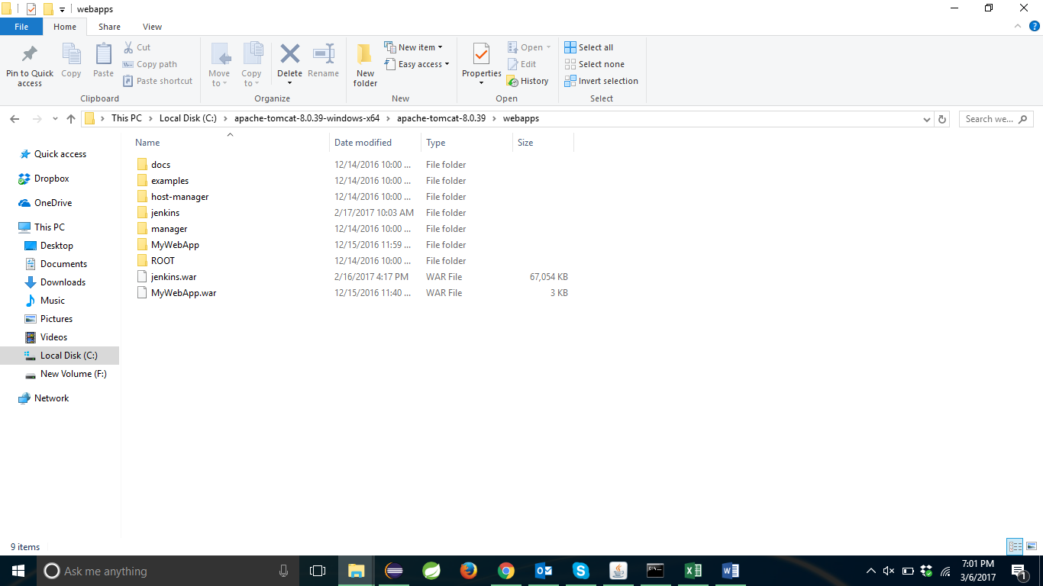

Step 3:

Start the Tomcat Server and run the Jenkins plugin.

Step 4:

Give the initial password and the installation will start automatically.

Step 5:

Configure with your credintials.